**Park #1**

[**https://www.conservationnw.org/news-updates/wolf-recovery-continues/**](https://www.conservationnw.org/news-updates/wolf-recovery-continues/)

**North cascade national park**

[**https://www.nps.gov/noca/learn/nature/wolves.htm**](https://www.nps.gov/noca/learn/nature/wolves.htm)

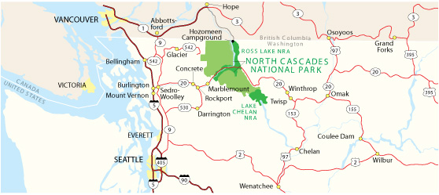

**ther species associated with wilderness areas that have been documented in the North Cascades include black bear, wolverine, river otter, cougar, lynx, and bobcat. Bats, the only mammals capable of true flight, are among our least understood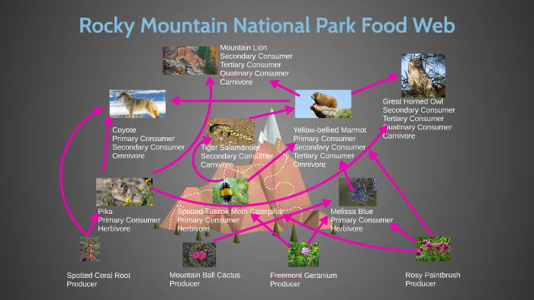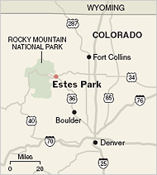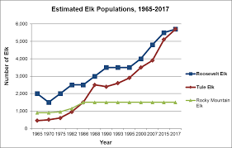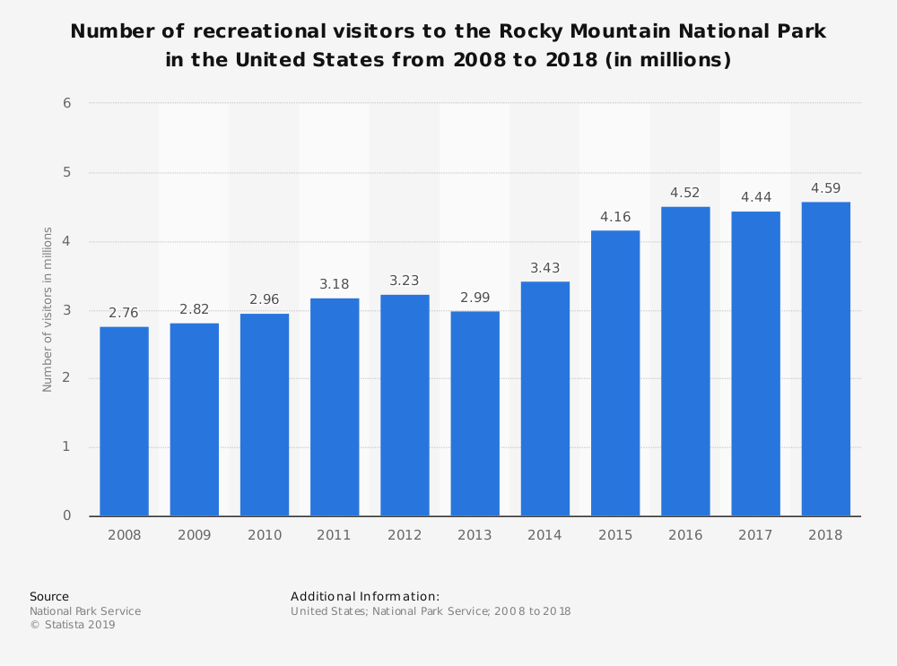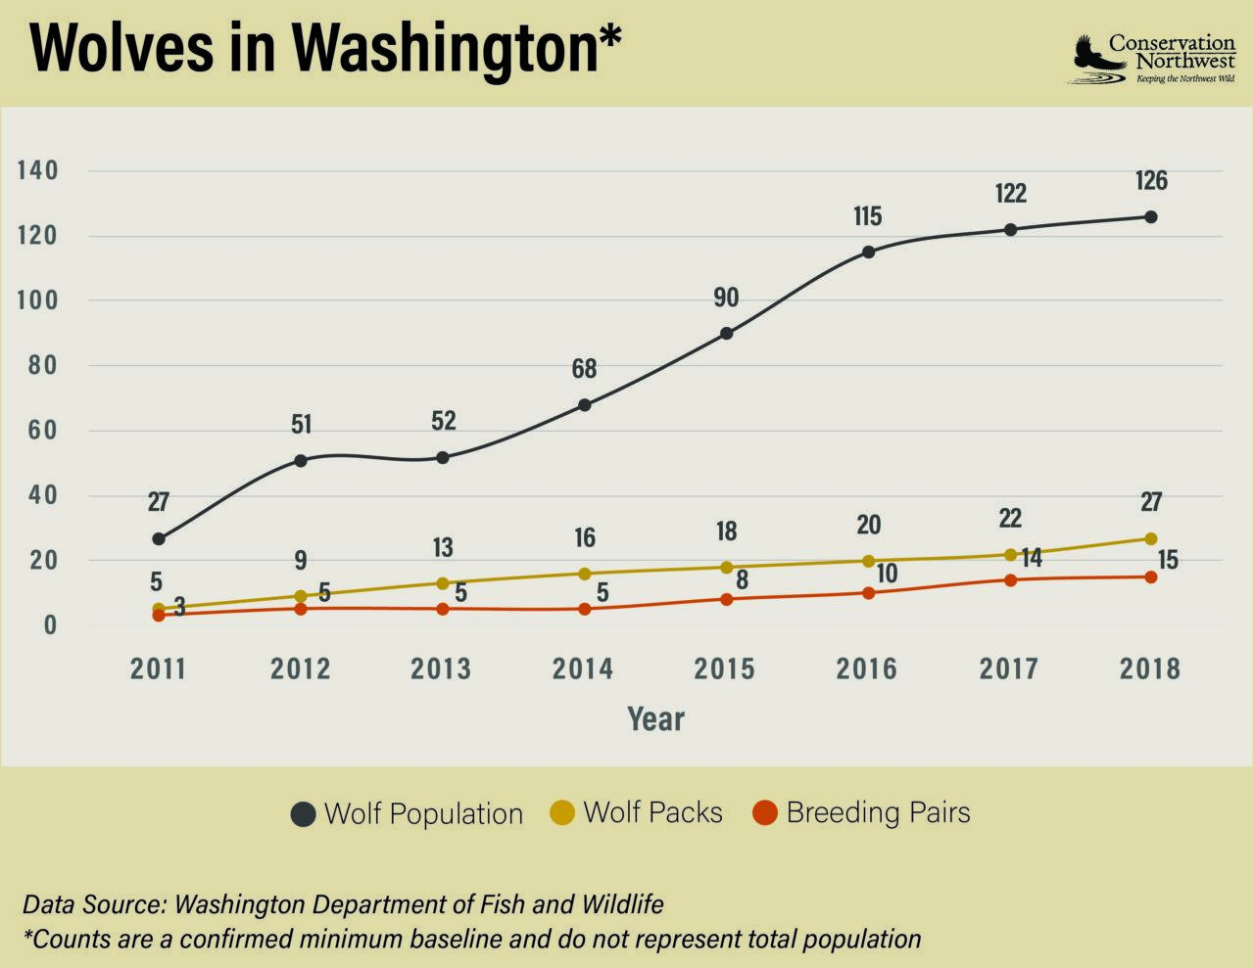 mammals.**

[**https://www.nps.gov/noca/learn/nature/mammals.htm**](https://www.nps.gov/noca/learn/nature/mammals.htm)

[**https://patch.com/washington/across-wa/first-wolf-pack-western-washington-seen-2018-wdfw**](https://patch.com/washington/across-wa/first-wolf-pack-western-washington-seen-2018-wdfw)

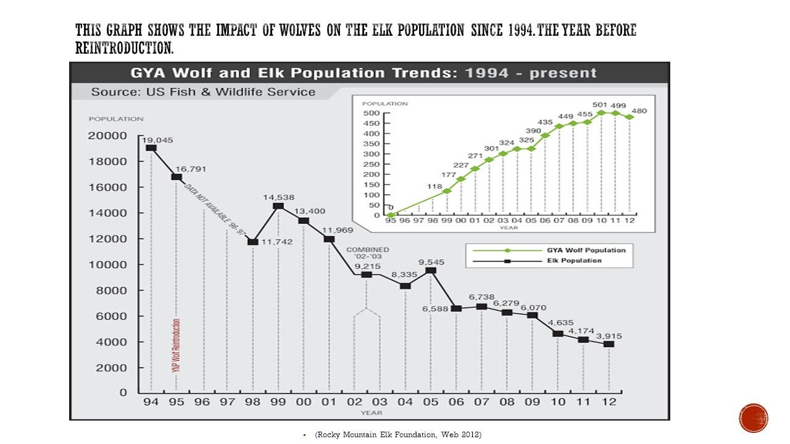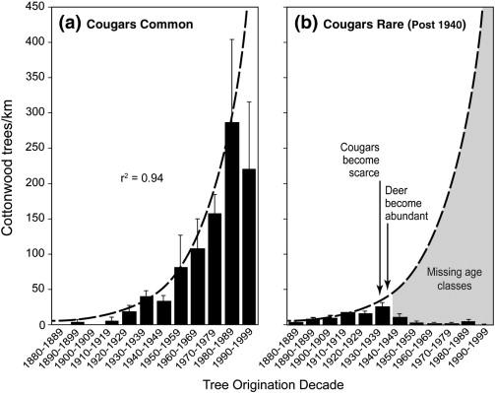

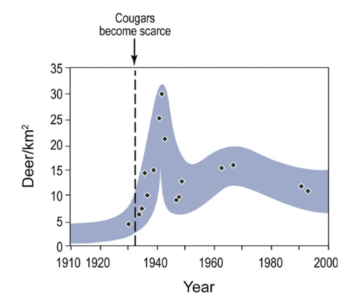

**Park 3**

**montana's glacier national park**

[**https://www.nps.gov/noca/learn/nature/wolves2.htm**](https://www.nps.gov/noca/learn/nature/wolves2.htm)

**General**

[**https://www.conservationnw.org/our-work/wildlife/gray-wolf/**](https://www.conservationnw.org/our-work/wildlife/gray-wolf/)

**Rocky Mountain Colorado**

[**https://www.nps.gov/romo/learn/nature/animals.htm**](https://www.nps.gov/romo/learn/nature/animals.htm)

**Grand Teton**

[**https://www.nps.gov/grte/learn/nature/mammals.htm**](https://www.nps.gov/grte/learn/nature/mammals.htm)